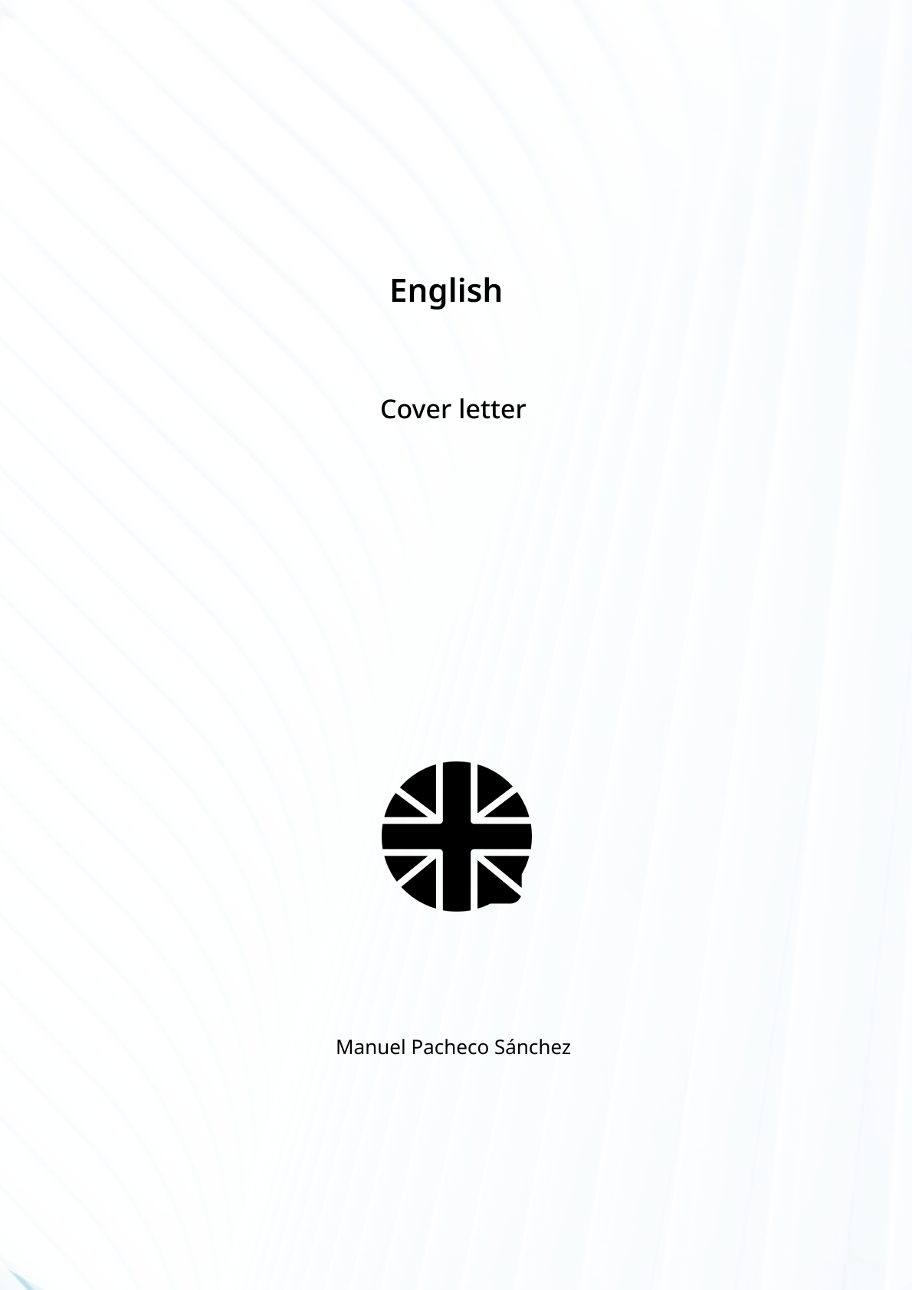

Dear sir / madam,

My name is Manuel Pacheco, and I am writing to express my interest in the Web Developer position I came across in your job advertisement on <https://arc.dev/>.

In addition to my educational background in Web Development and Systems Administration, I have a deep passion for technology that has been with me since childhood. What truly distinguishes me is my rapid learning ability and my comfort with tackling new problems and mastering new technologies. This agility is not apparent in my CV but is a fundamental aspect of my approach to web development. I believe in creating clean and maintainable code, which is critical for successful web projects. My previous experience in Java and JavaScript development, along with proficiency in HTML and CSS, aligns well with the responsibilities of the role.

I look forward to the possibility of discussing my qualifications further in an interview. Thank you for considering my application. Please feel free to contact me at +34 662151219 or via email at mpdevlp@gmail.com.

Yours sincerely,

Manuel Pacheco